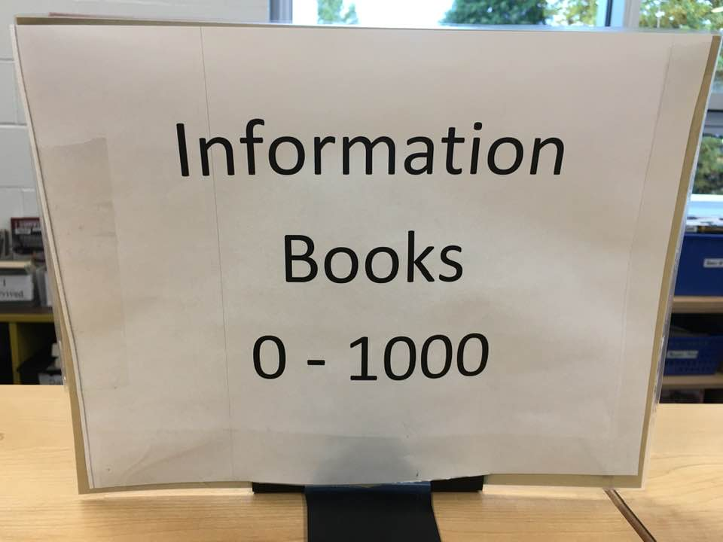

NON FICTION (Information Books)
A nonfiction book is one that tells you facts and information about the world around you. It can cover almost any topic, from wild animals to Vikings. If it's about something that really happened or something that really exists, it is nonfiction. Some nonfiction books have illustrations (pictures) as well as words.

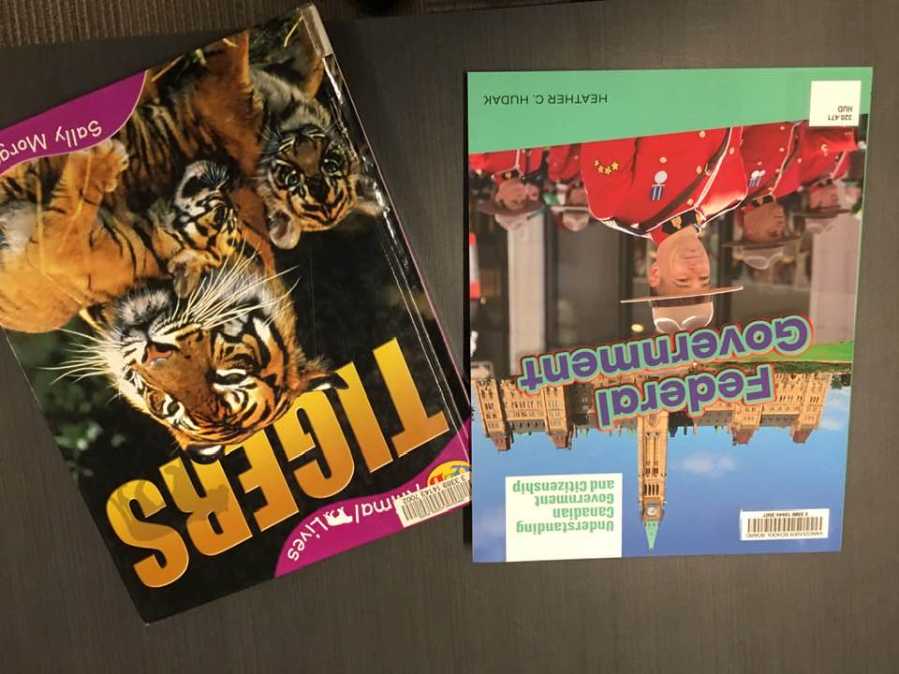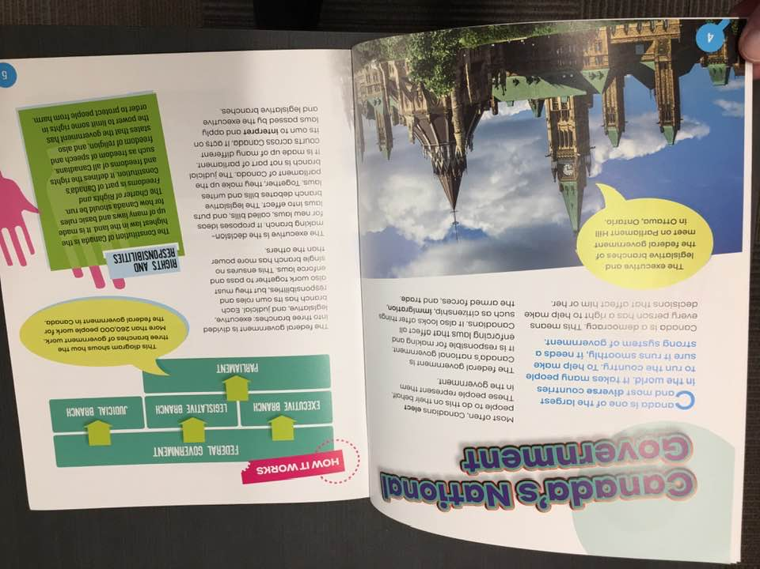
 | Federal government  Call #: 320.471 HUD Hudak, Heather C., 1975-  Series: Understanding Canadian government and citizenship  Published 2020  Interest Level: 3-6 | 1 of 1 available

How to find:
Go to the nonfiction section
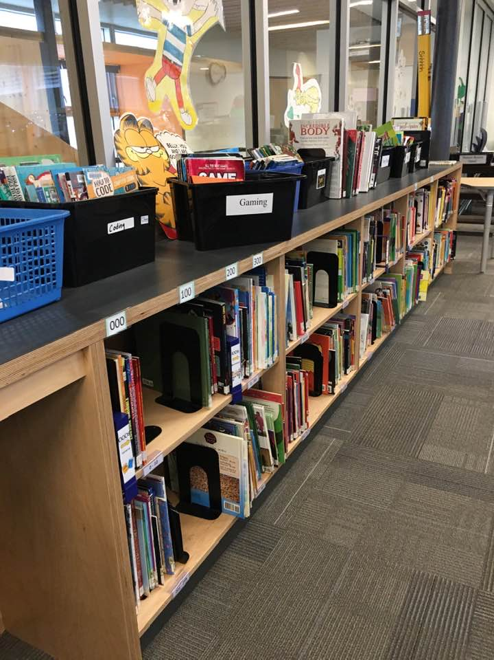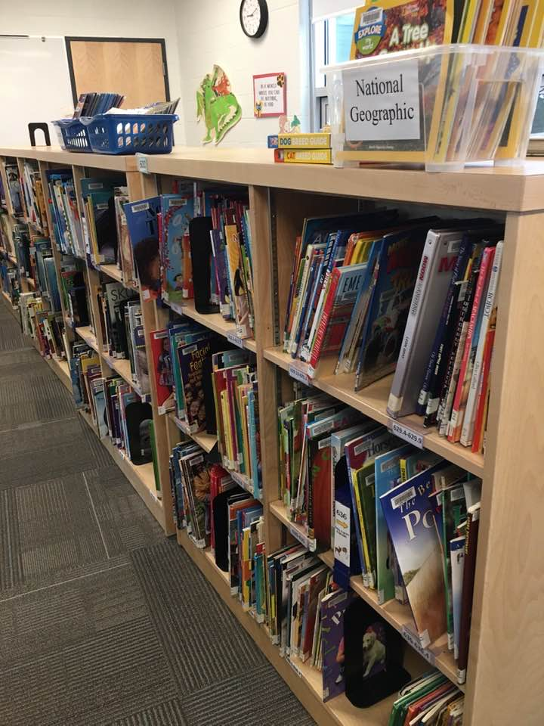
find the big numbers
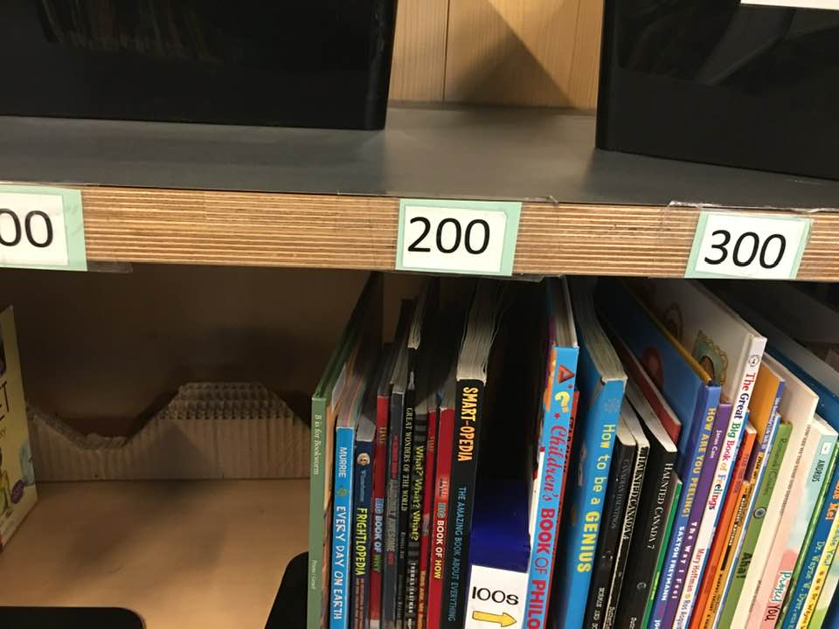
Find the specific shelf
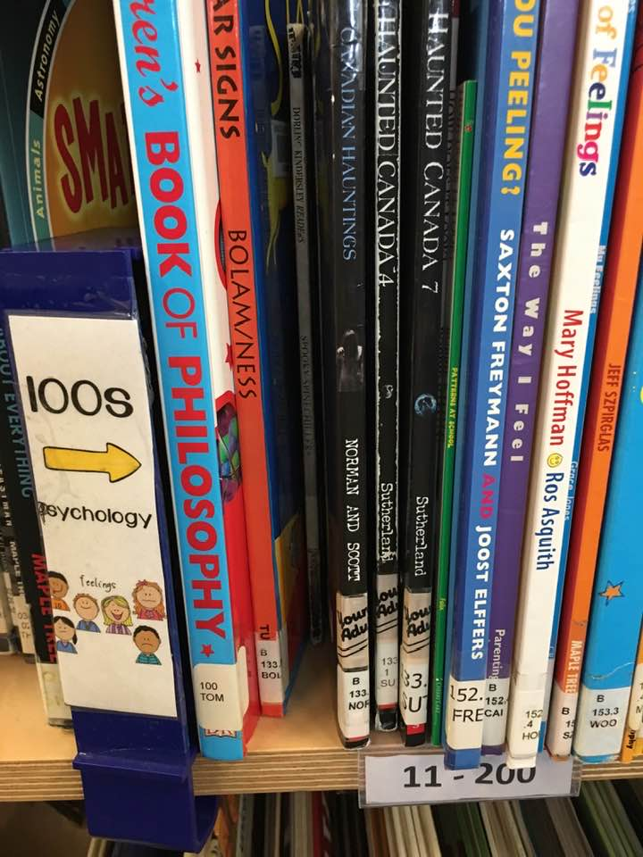

What can I expect inside the book?
- a table of contents (usually at the front)
A list of topics or parts of a book and the page numbers on which they begin
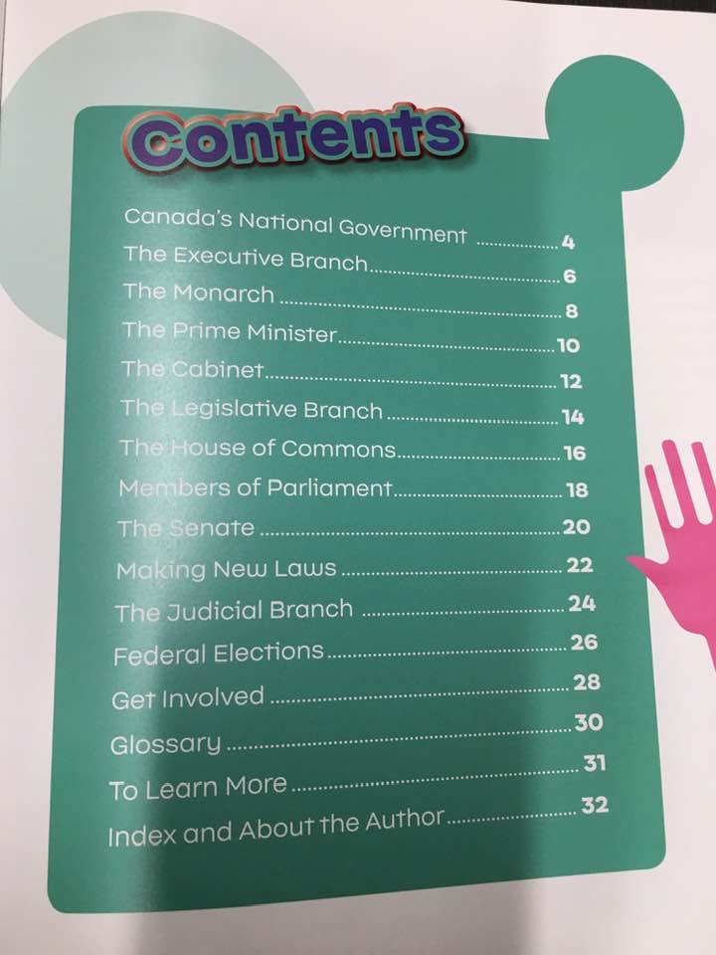
- An Index (usually at the back)
a list of names or topics given in alphabetical order and showing where each is to be found.

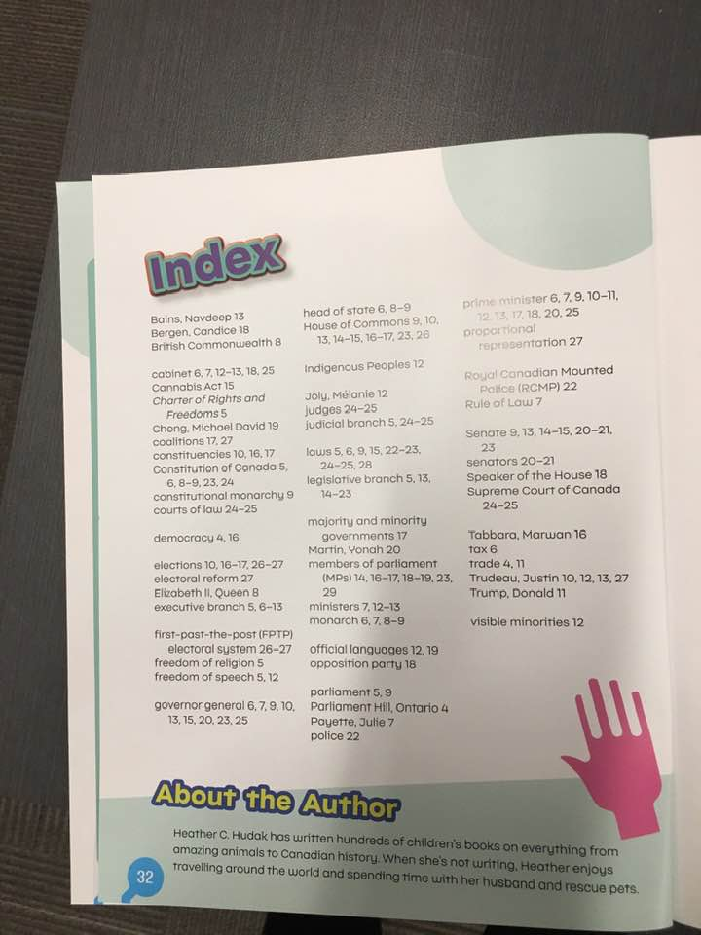

- A glossary (not always)
a list that provides definitions for the difficult or unusual words used in a book
